|  |  |
| --- | --- |
|  | **Mathematics Applications Year 12 ATMAA**  **Test 3 2020**  **Calculator Assumed. 1 page of notes – both sides.**  **NAME: ________________________________________**  *Circle Teacher:* Cheshire Le McRae Ryan  Time: 50 minutes Marks: $\frac{}{56}$ □ Units (- 1) □ Rounding (- 1)  *Show all working in the spaces provided*.  *Full marks may not be awarded without sufficient working.* |

**Question 1 [3 marks: 1, 1, 1]**

Examine the following time series and match each plot with one of the following data patterns.

**(i)** increasing secular trend  **(ii)** decreasing secular trend **(iii)** cyclic **(iv)** seasonal trend **(v)** random trend

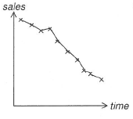

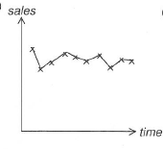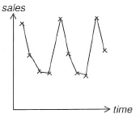 (c)

**(a)** ____________________ **(b)** __________________ **(c)** ___________________

**Question 2 [2 marks: 1, 1]** Examine the following time series shown below, then determine the most appropriate moving average which should be used to smooth the data.

**(a)** Moving Average: ______

|  |  |  |  |  |  |  |  |  |  |  |
| --- | --- | --- | --- | --- | --- | --- | --- | --- | --- | --- |
| **Time Period** | 1 | 2 | 3 | 4 | 5 | 6 | 7 | 8 | 9 | 10 |
| **Visitors (000’s)** | 24 | 28 | 19 | 17 | 21 | 15 | 10 | 18 | 12 | 10 |

**(b)** Moving Average: ______

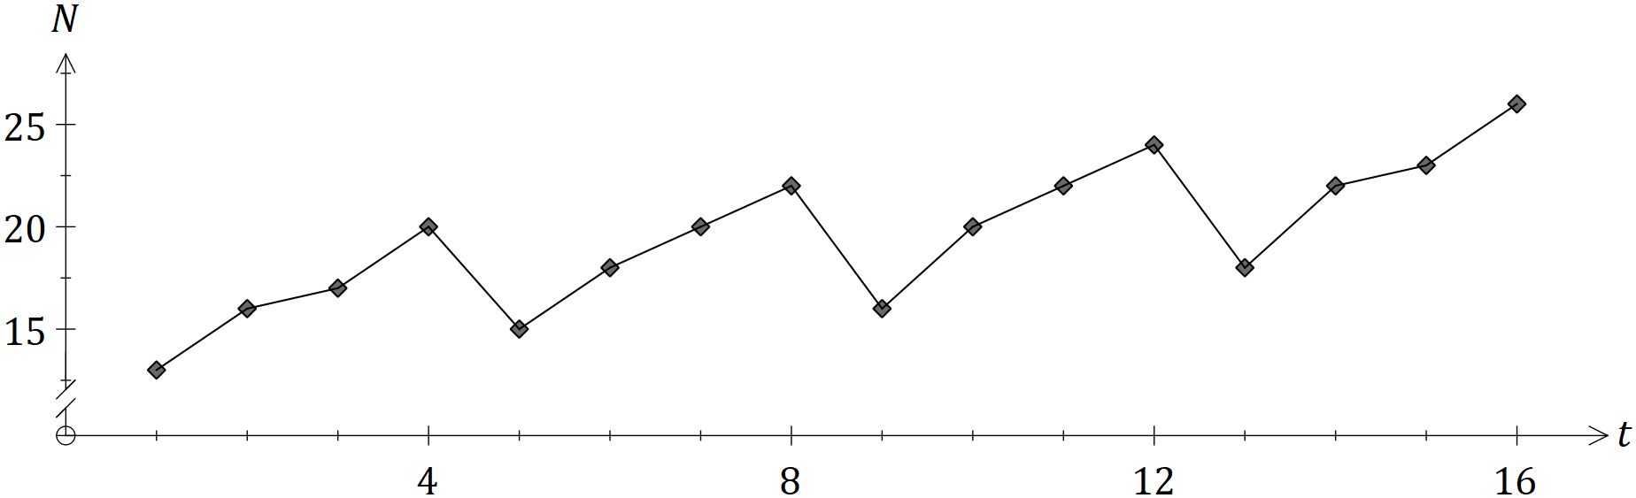

**Question 3 [16 marks: 4, 1, 4, 7]**

Each year, Australia exports tens of thousands of dairy cattle (cows) and breeding animals to countries all over the world to increase and improve herds through breeding programs. As the impact of COVID-19 continues to evolve, the Australian Livestock Exporters’ Council are focused on managing and minimising the impact that government actions and responses will have on the continuity and operation of this export industry. Data of the three previous years is given below.

|  |  |  |  |  |  |  |
| --- | --- | --- | --- | --- | --- | --- |
| **Time Period (t)** | **Year** | **Quarter** | **Value of exports ($million)** | **4pt CMA** | **Yearly mean** | **Percentage of yearly mean** |
| 1 | 2016 | March | **A** |  | 191.75 | 104.3 |
| 2 |  | June | 180 |  | 93.9 |
| 3 |  | September | 192 | 192.375 | 100.1 |
| 4 |  | December | 195 | 194.25 | 101.7 |
| 5 | 2017 | March | 205 | 195.875 | 196.5 | D |
| 6 |  | June | 190 | 196.375 | 96.7 |
| 7 |  | September | 195 | 198.375 | 99.2 |
| 8 |  | December | 196 | **B** | 99.7 |
| 9 | 2018 | March | 220 | 200.25 | **C** | 109.3 |
| 10 |  | June | 190 | 200.75 | 94.4 |
| 11 |  | September | 195 |  | 96.9 |
| 12 |  | December | 200 |  | 99.4 |

**(a)** Calculate the values of **A**, **B**, **C** and **D** from the above table.

|  |  |
| --- | --- |
| **A**: | **B**: |
| **C**: | **D**: |

**(b)**  Calculate the seasonal index for September and write this value in the table below.

|  |  |  |  |  |
| --- | --- | --- | --- | --- |
| Quarter | March | June | September | December |
| Seasonal Index (%) | 106.0 | 95.0 |  | 100.3 |

**(c)** **(i)** Calculate the deseasonalised value for June 2017.

**(ii)** Comment on the seasonal index found for June.

**(d)** The equation of the least-squares regression line for the deseasonalised value against time is

$$D=1.04t+189.73$$

1. Determine whether the dairy cattle and breeding animals are increasing or decreasing with time. Justify your answer with reference to the regression line. (2 marks)
2. Forecast the export value for June 2021. (3 marks)

1. Comment on the reliability of your forecast. (2 marks)

**Question 4 [3 marks]**

At the beginning of 2020, an electrical plant was purchased for $2.76 million. Financial consultants estimate that the plant will depreciate by 7.5% each year. Using the reducing balance method, determine the estimated value of this plant at the beginning of 2025.

Give your answer to the nearest thousand dollars.

**Question 5 [5 marks: 2, 2, 1]**

The average rainfall, in millilitres, is recorded for each season over a ten-year period. The given time series plot below shows the rainfall amount recorded during time period $t$.

**(a)** Describe the seasonality and trend of the time series.

**(b)** Explain the purpose of using the moving averages technique for time series data.

**(c)** Explain the reasoning of centring a $4$-point moving average.

**Question 6 [3 marks]**

Doctor Ryan Grug invested $4000 in a savings account, earning interest that is compounded monthly.

At the end of 5 years, the investment account had grown to $5007.18.

Determine the annual interest rate of Doctor Grug’s investment, to two decimal places.

**Question 7 [13 marks: 2, 2, 3, 6]**

The spreadsheet below shows the progress of a $40 000 loan for the first nine months.

|  |  |  |  |  |
| --- | --- | --- | --- | --- |
| **Month**  **(n)** | **Amount owed at the start of the month** | **Interest charged for the month** | **Repayment** | **Amount owed at the end of the month** |
| 1 | 40000.00 | 300.00 | 600 | 39700.00 |
| 2 | 39700.00 | 297.75 | 600 | 39397.75 |
| 3 | 39397.75 | **B** | 600 | **C** |
| 4 | **A** | 293.20 | 600 | 38786.43 |
| 5 | 38786.43 | 290.90 | 600 | 38477.33 |
| 6 | 38477.33 | 288.58 | 600 | 38165.91 |
| 7 | 38165.91 | 286.24 | 600 | 37852.16 |
| 8 | 37852.16 | 283.89 | 600 | 37536.05 |
| 9 | 37536.05 | 281.52 | 600 | 37217.57 |

**(a)** Show mathematically that the yearly interest rate is 9%.

**(b)** Write a recursive relation to determine the value of this loan at the end of each month.

**(c)** Determine the values of **A**, **B** and **C** in the table above.

|  |  |  |
| --- | --- | --- |
| **A:** | **B:** | **C:** |

**(d)** Determine

1. the number of repayments to fully repay the loan (2 marks)
2. the amount of the final repayment (2 marks)
3. the total interest charged over the life of the loan, to the nearest dollar. (2 marks)

**Question 8 [4 marks]**

AnhStrong is considering moving to Denmark, Western Australia from the beginning of September of this year. As there is a much smaller population in Denmark than Perth, AnhStrong believes she will not be as susceptible in catching the COVID virus. AnhStrong investigated all viable options to ensure she would have enough money to move from Perth to Denmark, including funds for her accommodation. Due to her research, AnhStrong is uncertain if she will have enough saved and is also unsure of how much she may need to borrow. She has narrowed her options to two as shown below.

Option A:

McrayFish Quest Loans with an interest rate of 5.20% per annum, compounded monthly.

Option B:

ChesHouse Tenis Bank with an interest rate of 5.30% per annum, compounded quarterly.

Determine which option AnhStrong should choose to maximise her savings and explain your reasoning.

**Question 9 [7 marks: 2, 1, 4]**

Colin places $5000 into an investment account which pays 3.9% p.a. where interest is compounded fortnightly. Colin then makes deposits of $150 at the end of each fortnight.

**(a)** Write a recurrence relation to give the value of the investment at the beginning of each fortnight.

**(b)**  How much money will be in the account after one fortnight?

**(c)** How many weeks will it take for Colin’s initial investment to double in value?

**END OF QUESTIONS**

**THIS PAGE HAS BEEN LEFT BLANK INTENTIONALLY**